|  |  |  |  |
| --- | --- | --- | --- |
| 1 | | 15,000.0 | |
| NUMERO DE FRONTERAS | | ENERGIA AGREGADA | |
|  | | | |
| NO | | 0 | |
| CONTRATO | | VENCIMIENTO CONTRATO | |
|  | | | |
| 36,693,296 | 85 | | 1,342,191 |
| INGRESO 2019 | DÍAS CERTIFICADOS 2019 | | ENERGIA RESPALDADA 2019 |
|  | | | |
| 54,621,628 | 155 | | 1,974,224 |
| INGRESO 2020 | DÍAS CERTIFICADOS 2020 | | ENERGIA RESPALDADA 2020 |
|  | | | |
| 9,133,172 | 26 | | 389,950 |
| INGRESO 2021 | DÍAS CERTIFICADOS 2021 | | ENERGIA RESPALDADA 2021 |

|  |
| --- |
| **GRAND HYATT**  USUARIO |

|  |
| --- |
| **Mateo Porras**  Ejecutivo de cuenta |

|  |
| --- |
| **Mauricio Ramos / Director de Ingenieria / mauricio.ramos@hyatt.com**  PUNTO FOCAL |

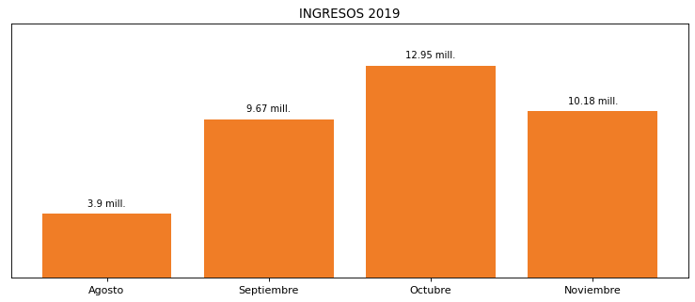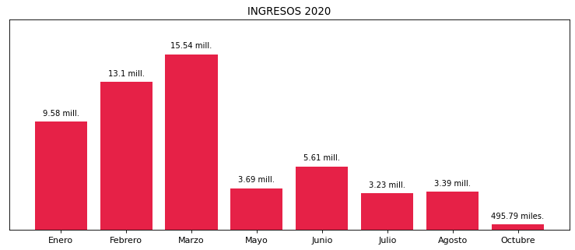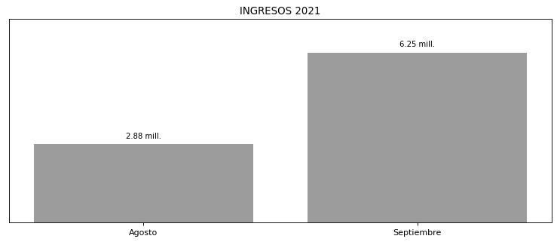

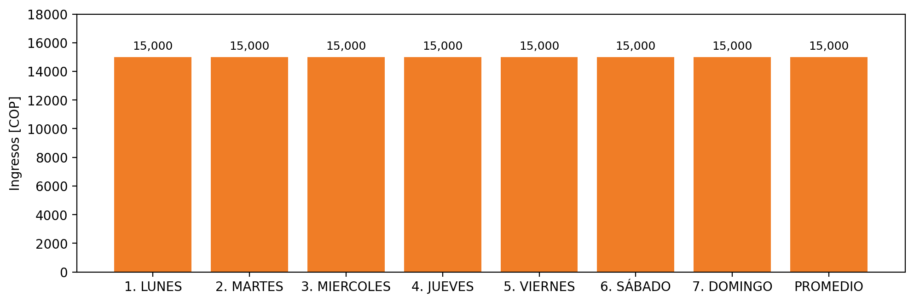

|  |  |  |  |  |  |  |  |  |  |  |
| --- | --- | --- | --- | --- | --- | --- | --- | --- | --- | --- |
| **FRONTERA** | **COD SIC** | **PREDIO** | **FRT DDV** | **TIPO DDV** | **PROMEDIO** | **PRÓXIMA ACTUALIZACIÓN** | **MARGEN DE ERROR** | **ÚLTIMA PRUEBA DDV** | **DÍAS PARTICIPACIÓN** | **FECHA REFERENCIA PRÓXIMA PRUEBA DDV** |
| FIDEICOMISO HOTEL GRAND HYATT CEMSA | Frt32311 | Prd01339 | Frt42313 | GPE | 15,000 | 2026-04-15 | NO APLICA | 2021-08-10 | 26.0 | 2022-01-16 |